On the Defensive:
Identity, Language, and Partisan Reactions to Political Scandal

Pierce D. Ekstrom
Dept of Political Science, University of Nebraksa – Lincoln
Oldfather Hall, 660 N 12th St, Lincoln, NE 68588
pierce.ekstrom@unl.edu

Marti Hope Gonzales
Dept of Psychology, University of Minnesota
gonza001@umn.edu

Allison L. Williams
Beech Acres Parenting Center
williams.ally@gmail.com

Elliot Weiner
Relay Graduate School of Education
eweiner@relay.edu

Rafael Aguilera
University of Texas at El Paso
raguilera3@miners.utep.edu

Word Count: 9,999
(Excluding tables & figures, including references, notes, and abstract)
Last Updated: 09/26/2023
Abstract
We investigated how individuals judge politicians embroiled in scandal. Drawing on social identity and realistic group conflict theory, we predicted that beyond an overall ingroup bias, partisans would be particularly forgiving of in-party politicians who denied or justified their misconduct rather than apologize for it. By insisting that they did nothing wrong, these politicians defend the public image of their party and signal their commitment to partisan goals. We find qualified support for this prediction across three experiments. Participants did not respond negatively to in-party politicians who apologized, but they did react more positively to those who denied or justified wrongdoing (relative to silence). These accounts only worked for in-party politicians and were more effective for those whose misconduct furthered their party’s agenda or whose seat was high-status or pivotal for party goals. In intergroup contexts like politics, people may accept explanations for misconduct that they would otherwise find offensive.

Keywords: group processes, political psychology, conflict, communication, scandal

On the Defensive: Identity, Language, and Partisan Reactions to Political Scandal
In October 2016, Donald Trump was heard to assert on the “Access Hollywood” tape, “…And when you’re a star, they [women] let you do it. You can do anything…Grab ’em by the pussy. You can do anything.” Public outrage did not translate into electoral defeat. In December 1998, President Bill Clinton was impeached by the U.S. House of Representatives. Charged with both obstruction of justice and lying to a grand jury about his sexual relationship with a White House intern, Clinton was spared by the U.S. Senate and completed his second term in office. Among his more memorable responses to accusations against him were contents of a speech delivered to the American public: “[…] I want you to listen to me. I'm going to say this again: I did not have sexual relations with that woman, Miss Lewinsky. I never told anybody to lie, not a single time, never. These allegations are false...” These and many other politicians—from Ted Kennedy, to Richard Nixon, to Ronald Reagan, to Roy Moore—have confronted and responded to allegations of serious misconduct.
Political scandals have become part and parcel of contemporary American life—and so too, apparently, has the possibility that elites accused of wrongdoing will maintain the support of their party. We investigated the role of rhetoric in this process and how it interacts with partisan motives. We used three experiments to test whether, when, and why politicians can safely employ “aggravating” strategies that deny or justify their actions rather than “mitigating” strategies that concede wrongdoing and work toward reconciliation. We find that partisans were especially willing to tolerate aggravating strategies from leaders from their own party, that this tendency is associated with participants’ concern with their party’s reputation, and that it is exacerbated when they believe their party’s political agenda is threatened.
We focus primarily on political scandal, but our results may help answer broader questions: How do people perceive and respond to ingroup wrongdoing? How do the rhetorical strategies that “work” for ingroup transgressors differ from or resemble those that work for individual transgressors? Our results suggest that individuals’ desire to preserve the esteem of their group and to see its goals achieved may incline them to tolerate—if not to actively reward—leaders who insist on their innocence rather than admit their faults.
Ingroup Favoritism and Evaluations of Errant Politicians
People tend to favor ingroup members over outgroup members, even when the boundaries that divide those groups are transparently arbitrary (e.g., Diehl, 1990; Locksley et al., 1980; Tajfel, 1970). This tendency is attributable to at least two processes. First, groups often compete for scarce resources, and this competition sours intergroup relations (Sherif et al., 1961). Second, people hold their ingroups in high esteem to the extent that they see those groups as part of who they are (Crocker & Major, 1989; Tajfel & Turner, 1986).
Political parties both compete for scarce resources (e.g., government funding, elected offices, legislation) and define important social identities (Campbell et al., 1960). Accordingly, partisanship influences how people perceive and treat one another in political contexts (Mason, 2018), including political actors accused of misconduct. When politicians belong to their own party rather than another, people evaluate them more leniently (Bhatti et al., 2013; Chanley, et al., 1994; Costa et al., 2020; Gonzales et al., 1995) and are more likely to mistakenly believe that they are innocent in the first place (Dimock & Jacobson, 1995).
That said, party loyalty has limits. Partisans who are politically knowledgeable are less biased by partisanship in their perceptions of corruption (Anduiza et al., 2013). And sometimes politicians credibly accused of serious misconduct—like Roy Moore in Alabama, who was accused of serious sexual misconduct—can lose elections, even when their party holds a secure majority. So, shared partisanship may not always motivate people to forgive errant politicians. Indeed, media coverage of overt wrongdoing might be one of the few things that can alienate partisan leaders from their supporters. Previous research shows that voters’ reactions—or nonreactions—to politicians’ misconduct depends on how those politicians choose to explain it.
Transgressions and Accounts in Politics and Beyond
Errant actors’ explanations for their conduct are called accounts (e.g., Gonzales et al., 1992; Schönbach, 1990; Scott & Lyman, 1968). When accounting for their behavior, transgressors must balance at least two competing concerns: to re-establish themselves as moral, competent people, and to repair their relationship with the victims of or witnesses to their alleged transgression. Acknowledging wrongdoing may embarrass an actor, but denial may anger skeptical observers. The balance that any given account strikes between these concerns places that account along a continuum from mitigating (or “accommodative,” such as apologies or excuses) to aggravating (or “defensive,” such as justifications or denials; Coombs, 1998; Gonzales et al., 1990; McLaughlin et al., 1983).
Politicians accused of wrongdoing are faced with these competing pressures to preserve their public image and to soothe potentially angry voters. However, politicians must navigate the consequences of their behavior not only for themselves but also for their party as a group—both to maintain its public image and to pursue its material goals. First, politicians who rely on aggravating accounts defend both their own public image and their party’s, affirming partisans’ social identity; with mitigating accounts, in contrast, wrongdoers risk making themselves and their party appear immoral. Second, by contesting the idea that politicians did wrong in the first place, aggravating accounts attest that they can be trusted with the power that partisans require to achieve their goals. Some aggravating accounts even frame a scandal explicitly as a partisan conflict (e.g., an illegitimate witch hunt) with the politician’s victory the prize. Mitigating accounts, in contrast, may imply that errant politicians intend (or ought) to give up their seat to a worthier alternative, lending credibility to out-party critics and forfeiting party power. In short, politicians can wield aggravating accounts to affirm the collective esteem of the party and to defend its goals from threats, whereas those who employ mitigating accounts may seem to put their party’s public image and its goals at risk. Partisans may therefore derogate co-partisan politicians who use mitigating accounts and rally behind those who use aggravating accounts—either because they value the collective esteem of the party or because they value what the party can achieve in office. This tendency would incentivize politicians to use aggravating over mitigating accounts to cope with allegations of misconduct, given that they tend to rely heavily on support from members of their own party (Holbrook & McClurg, 2005).
Although we are unaware of any direct evidence that partisans prefer aggravating over mitigating accounts, extant research is suggestive. For example, participants responded more favorably to unpopular votes when (fictitious) politicians used justifications (which minimize wrongdoing) rather than excuses (which concede wrongdoing but attempt to shift blame) (McGraw et al., 1995; McGraw et al., 1993). Gonzales and colleagues (1995) found that although participants generally preferred justifications to refusals, they were more likely to accept refusals from members of their own party. In short, and in contrast to studies of interpersonal conflict and wrongdoing (e.g., Benoit & Drew, 1997; McCullough et al., 1997), aggravating accounts may “work” for political leaders—because they can rely on co-partisans.
Study Overview and Hypotheses
In the present studies, we examine individuals’ reactions to fictitious politicians’ accounts in the wake of scandal. With Study 1, we worked to identify which accounts elicit the most favorable reactions. We predicted:
H1a. Aggravating accounts (that deny wrongdoing) will improve participants’ evaluations of politicians from their own party (relative to a no-account control condition).
H1b. Mitigating accounts (that concede wrongdoing) will degrade participants’ evaluations of politicians from their own party (relative to control).
Together, these predictions comprise our Defend-the-Group Hypothesis (H1): evaluators will respond more favorably to (allegedly) errant politicians who defend their behavior than to those who apologize for it.
We further predicted that this tendency would be strongest among participants whose partisanship was most central to their identity, who presumably would be most motivated to defend their political ingroup (H2: Identity Centrality Hypothesis).
We conducted Studies 2 and 3 to replicate Study 1 and to clarify when and why participants accepted aggravating accounts. Specifically, we tested whether aggravating accounts improve participants’ evaluations of politicians from their own party when or to the extent that:
Politicians’ actions have implications for their party’s collective esteem (H3: Image-Defense Hypothesis).
Politicians’ actions might further or impede the party’s pursuit of power or desired policies (H4: Goal-Defense Hypothesis).
H3 and H4 are not mutually exclusive. Both intergroup competition and the desire to maintain positive, distinctive social identities contribute to ingroup favoritism, and aggravating accounts from a party leader can simultaneously affirm the party’s positive identity and protect its hold on power by forcefully claiming, “I did nothing wrong!”
Materials, data, and scripts for all three studies are available on the Open Science Framework at: https://osf.io/ary9u/?view_only=1c6078fa2a4b4940a4aa2a72b7fe4e4d. Analyses were not preregistered.
Study 1
Our first experiment tested our hypotheses that aggravating accounts would elicit relatively positive reactions from co-partisans, that mitigating accounts would elicit negative reactions, and that the beneficial effects of aggravating accounts would be strongest among evaluators whose partisanship is highly central to their identity. In this study, we tested our hypotheses in conditions especially likely to promote the ingroup bias that we predict—when a high-status politician is accused of misconduct that intentionally furthers his own party’s agenda. Null findings in this context would provide strong evidence against hypotheses.
All participants read a fictitious news story about a high-status politician accused of misconduct. To test the Defend-the-Group Hypothesis (H1), we manipulated the partisan allegiance of that politician (Democrat or Republican) and the account that he offered to explain his behavior (mitigating, aggravating, or none), then examined participants’ evaluations of that politician. To test the Identity Centrality Hypothesis (H2), we asked participants to report the centrality of their partisan affiliation to their identity and examined this variable as a moderator of the effects of each account. We predicted that the beneficial effects of aggravating accounts and detrimental effects of mitigating accounts would both be more pronounced among those for whom partisanship was more central to their identity.
Method
Participants
We recruited participants from Amazon’s Mechanical Turk (N = 578). Because we were primarily interested in partisan reactions to political scandal, we excluded from our analyses self-described Independents (n = 102) and those who skipped or did not reach the party identification question (n = 73), retaining Independents who “leaned” toward a particular party. This produced a sample (N = 403) that contained 156 men and 242 women with mean age 35.80 years (SD = 13.65 years). 331 participants identified as White, 37 as Black, 18 as Latino/Hispanic, 19 as Asian, 9 as Native American, and 5 as another race/ethnicity.
Materials and Procedure
We told participants that we were interested in “responses to current events” and randomly assigned them to read and respond to one of 18 fictitious news stories describing a political scandal. Unless otherwise noted, all continuous measures were recoded to range from 0 to 1 to aid in the interpretation of effect sizes (Cohen et al., 1999).
News Story Manipulation. Participants read a fictitious news story about a high-ranking politician, Roger Wimsatt, who had been accused of wrongdoing. We manipulated Wimsatt’s political party, the account he gave, and the misdeed of which he was accused (i.e., the scandal scenario).
Political party. Wimsatt was described as a high-ranking Democratic or Republican Party official. Because we included only partisans, each participant was effectively assigned to an in-party or out-party politician condition.
Account. In response to accusations of misconduct, Wimsatt provided an aggravating account, a mitigating account, or no account. In the aggravating account condition, Wimsatt said that his actions were necessary to accomplish the party’s goals and that given the chance, he would do it all over again. In the mitigating account condition, Wimsatt said that the course of action that he took was wrong, but he was under a great deal of pressure to accomplish the party’s agenda. He apologized for his actions and indicated that he would have done otherwise if given the choice. In the no-account control condition, Wimsatt was expected to call a press conference by the end of the week.
Scandal Scenario. We also tested whether our hypothesized effects generalized across different kinds of scandals. In the political coercion condition, Wimsatt used his influence as a senior party official to threaten or blackmail legislators into changing their vote on the Affordable Care Act. In the preferential treatment condition, Wimsatt used his influence to award government contracts to businesses with close ties to the party. In the electronic surveillance condition, Wimsatt used his influence to plant electronic surveillance spy-ware in dozens of businesses across the country.
Memory Checks. Immediately after reading the story, participants answered a series of multiple-choice questions about Wimsatt’s job, party, alleged misconduct, and response to that allegation to indicate what they remembered about the story.
Target Evaluations. Trait evaluations were measured using 9-point response scales anchored by nine semantic-differential-like adjective pairs, such as incompetent-competent and unlikeable-likeable. Action evaluations were measured using seven Likert-type items, including “How likely would you be to forgive Roger Wimsatt’s actions?” (from not at all likely to extremely likely) and “How angry do you feel after Roger Wimsatt’s explanation for his actions?” (from not at all angry to extremely angry). We developed these items ad hoc to measure various reactions and impressions, but because they turned out to be closely interrelated, (α = .89) we rescored all 16 items to range from 0 (very negative) to 1 (very positive) and averaged them in a single scale.
Partisanship. Participants reported their partisanship using a single 7-point item with the response options Strong Democrat, Democrat, Independent/Leaning Democrat, Independent, Independent/Leaning Republican, Republican, Strong Republican. In line with work suggesting that independent voters tend to vote with the party toward which they lean (Abramowitz, 2010; Campbell et al., 1960), we counted independent “leaners” as partisans. We excluded non-leaners from analysis.
Partisan Identity Centrality. We measured partisan identity centrality using three items adapted from the identity subscale of the collective self-esteem scale (Luhtanen & Crocker, 1992) such as “The political party I belong to is an important reflection of who I am” (α = .83).
Exploratory Variables. We also measured political ideology, attitudes toward each major party, political cynicism, knowledge, interest, and media consumption. We had no specific hypotheses concerning any of these variables in our study.
Results
Analytic Strategy
We ran a series of regressions predicting evaluations of Wimsatt from account type (mitigating, aggravating, or none), politician party (ingroup vs outgroup), and the interactions between the corresponding indicator variables.
We excluded participants (67 of 403 partisan respondents) who incorrectly answered our memory checks about the politician’s party, misconduct, or account. Analyses reported in the supplement suggest that exclusion was adequately balanced across conditions and unlikely to have biased our results.
Effects of Accounts among Co-Partisans
Consistent with H1a, aggravating accounts improved participants’ evaluations of Wimsatt only when they identified with his party. Among participants who read about a politician from their own party, the estimated marginal effect (or “simple slope”) for aggravating accounts relative to the no-account control condition was significant, positive, and of moderate magnitude, corresponding about 15% of the scale’s full range. Aggravating accounts yielded no such benefit when the politician was from the opposing party.
H1b predicted that same-party evaluators would respond negatively to mitigating accounts. Our results were inconsistent with this hypothesis. Although the effect of mitigating accounts among same-party evaluators was small, nonsignificant, and considerably smaller than the effect of aggravating accounts among this group, it was not negative. Mitigating accounts did not help, but they were no worse than remaining silent. Neither account improved evaluations of out-party politicians.
See Table 1, Model 1.1 and Figure 1.
Did the effects of accounts depend on the type of scandal or partisan identity centrality?
To explore the possibility that the effects of accounts depend on the transgression that they attempt to address, we estimated mixed linear models in which the effects of account, politician party, and the interactions between them were allowed to vary randomly across the three scandal scenarios (coercion, surveillance, and preferential treatment). Effects differed only trivially across scenarios, with all slopes’ variance estimates less than 0.001 (which is less than 5% of any coefficient’s standard error in the model). Our results were therefore consistent across scandal scenarios. The supplement presents these estimates.
Our final prediction in Study 1 was that the preference for aggravating accounts from in-party politicians would be most pronounced among strong partisan identifiers. Collapsing across scenarios, we examined the three-way interaction among partisan identity centrality, politician party, and account. All lower-order terms were also included in the model. Contrary to our predictions, we found no evidence that participants’ responses to mitigating or aggravating accounts depended on the centrality of partisanship to their identity (b_{in-partyXmitigatingXcentrality} = -.10, 95% CI: -0.44, 0.24, p = 0.556; bin-partyXaggravatingXcentrality = -0.15, 95% CI: -0.48, 0.18, p = 0.381).
Discussion
Study 1 results were consistent with our Defend-the-Group Hypothesis, but only because partisans responded favorably to aggravating accounts from in-party politicians. Mitigating accounts did not do the harm we expected. Moreover, the absence of a moderating effect of partisan-identity centrality calls our theoretical account into question. If partisans prefer aggravating accounts because these accounts affirm their identity, then why was this preference no more pronounced among those with stronger identities? Perhaps our power was insufficient. With 336 subjects, we would have 0.6 power to detect the focal 3-way interaction if it accounted for half as much unique variance as the Aggravating Account x In-Party interaction.
Another possibility is that our manipulations (by design) made all participants’ partisan identities salient. The fictitious politician was “the official face of the Democratic/Republican Party’s central structure within Congress,” and his misconduct always advanced his party’s goals. If aggravating accounts “work” because they affirm partisans’ identities and exploit their desire to defeat their opponents, our news stories may have rendered even moderate partisans unusually susceptible to aggravating accounts.
In Study 2, therefore, we systematically manipulated whether the politician’s misbehavior put at stake his party’s esteem and its material goals. This design more directly manipulates our proposed mechanisms, rather than relying on natural variance in participants’ identity centrality. We also worked to recruit a larger sample, so that at least 600 participants would qualify for inclusion, affording a power of 0.99 to detect an effect size f² = 0.030 (the effect size of the Aggravating Account x In-Party interaction in Study 1), and a power of .85 to detect an effect half that size in terms of f².
Table 1. Testing the Defend-the-Group Hypothesis across Studies 1-3
 | Study 1 |  |  |  |  |  | Study 2 |  |  |  | Study 3
 | Target Evaluations (Model 1.1) |  |  |  |  | Target Evaluations (Model 1.2) |  |  |  |  | Trait Evaluations (Model 1.3) |  |  |  | Intent to Support (Model 1.4)
 | b |  | 95% CI |  | p | b |  | 95% CI | p |  | b | 95% CI |  | p | b | 95% CI |  |  | p
Ingroup Politician | 0.05 |  | [-0.01, 0.10] |  | 0.126 | 0.05* |  | [0.01,0.10] | 0.011 |  | 0.06*** | [0.03, 0.09] |  | < 0.001 | 0.14*** | [0.10,0.17] |  |  | < 0.001
Mitigating Account | -0.02 |  | [-0.08, 0.04] |  | 0.462 | 0.06** |  | [0.02,0.10] | 0.005 |  | 0.04** | [0.01, 0.07] |  | 0.007 | 0.03 | [-0.01,0.06] |  |  | 0.126
Aggravating Account | 0.00 |  | [-0.06, 0.06] |  | 0.984 | 0.01 |  | [-0.04,0.05] | 0.790 |  | -0.02 | [-0.05, 0.01] |  | 0.321 | 0.03† | [-0.00,0.06] |  |  | 0.082
Mitigating Acct X Ingroup | 0.06 |  | [-0.03, 0.14] |  | 0.201 | 0.03 |  | [-0.03,0.09] | 0.278 |  | 0.03 | [-0.01, 0.07] |  | 0.108 | 0.02 | [-0.03,0.07] |  |  | 0.410
Aggravating Acct X Ingroup | 0.15** |  | [0.06, 0.23] |  | 0.001 | 0.12*** |  | [0.06,0.18] | <0.000 |  | 0.07** | [0.03, 0.11] |  | 0.001 | 0.05† | [-0.00,0.09] |  |  | 0.062
Intercept | 0.31*** |  | [0.27, 0.35] |  | < 0.001 | 0.25*** |  | [0.22,0.28] | <0.001 |  | 0.24*** | [0.22, 0.26] |  | < 0.001 | 0.03* | [0.00,0.05] |  |  | 0.025
Conditional Effects of Accounts by Politician Partisanship
For In-Party Politicians
Aggravating account | 0.15*** |  | [0.09, 0.21] |  | < 0.001 | 0.12*** |  | [0.08, 0.16] | < 0.001 |  | 0.06*** | [0.02, 0.09] |  | < 0.001 | 0.08*** | [0.04, 0.11] |  |  | < 0.001
Mitigating Account | 0.03 |  | [-0.03, 0.09] |  | 0.281 | 0.09*** |  | [0.05, 0.14] | < 0.001 |  | 0.07*** | [0.05, 0.10] |  | < 0.001 | 0.05** | [0.01, 0.08] |  |  | 0.006
For Out-Party Politicians
Aggravating account | 0.00 |  | [-0.06, 0.06] |  | 0.984 | 0.01 |  | [-0.04, 0.05] | 0.790 |  | -0.02 | [-0.05, 0.01] |  | 0.321 | 0.03† | [-0.00, 0.06] |  |  | 0.082
Mitigating Account | -0.02 |  | [-0.08, 0.04] |  | 0.462 | 0.06** |  | [0.02, 0.010] | 0.005 |  | 0.04** | [0.01, 0.07] |  | 0.007 | 0.03 | [-0.01, 0.06] |  |  | 0.126
 | F(5, 330) |  |  | 14.17*** |  | F(5, 642) |  | 25.32*** |  |  | F(5, 1,457) |  | 33.92*** |  | F(5, 1,454) |  |  | 58.31***
 | R² |  | .18 |  |  | R² |  | .16 |  |  | R² |  | .10 |  | R² |  | 0.17
 | N |  | 336 |  |  | N |  | 648 |  |  | N |  | 1,463 |  | N |  | 1,460
Note. Entries are estimates from OLS regressions of target evaluations, trait evaluations, or intent to support (all scaled to range from 0 to 1) on indicator variables for account, politician partisanship, and the interaction between these indicators.
† p < 0.1; * p < 0.05; ** p < 0.01; *** p < 0.001

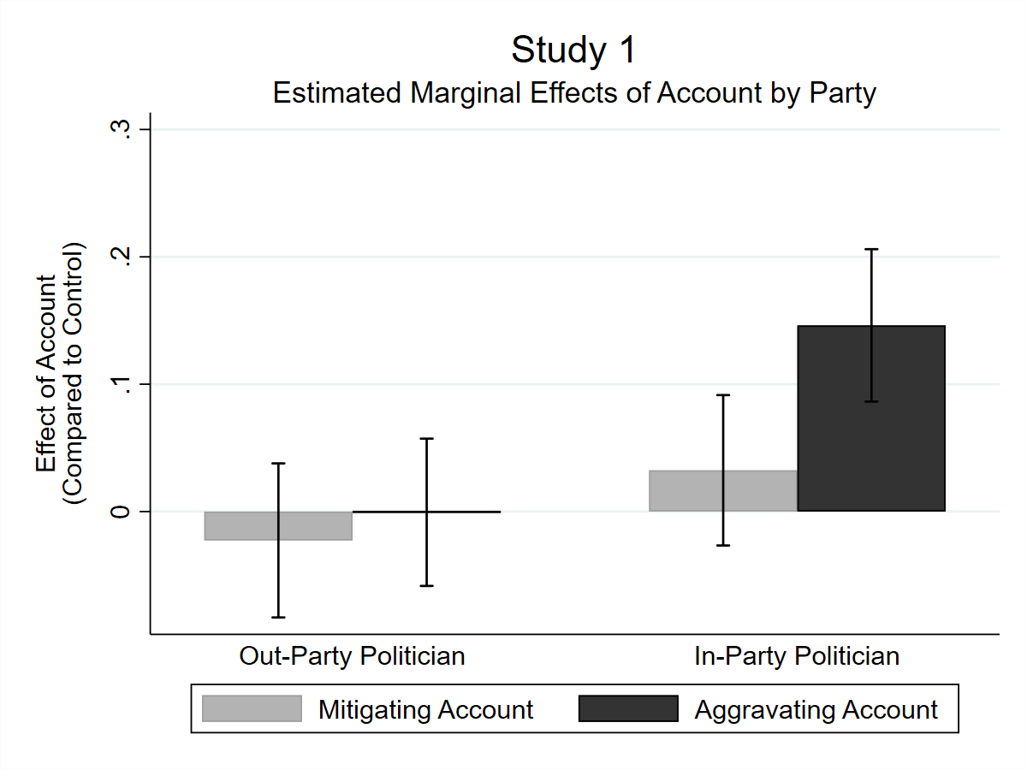
Figure 1. Each bar represents the estimated marginal effect (or “simple slope”) of aggravating accounts or of mitigating accounts on target evaluations (scaled 0 to 1), relative to the no-account control condition. Error bars indicate 95% CIs. Based on estimates from Table 1, Model 1.1.

Study 2
In Study 2, we repeated our tests of the Defend-the-Group Hypothesis (H1) and the moderating role of identity centrality (H2). We also added two manipulations. First, we manipulated the status of the politician within his party (high status and central to the group versus low status and ancillary to the group) and therefore the implications of his actions for his party’s collective image. Second, we manipulated whether the politician’s actions served his party’s collective goals versus his own personal ones and thus whether his actions were situated in the context of partisan conflict for power. We predicted that participants’ favorable reactions to politicians who used aggravating accounts would be most pronounced when the politician’s status within his party was high (consistent with the Image-Defense Hypothesis, H3) and when the scandal furthered his party’s goals (consistent with the Goal-Defense Hypothesis, H4).
Method
Participants
As in Study 1, we recruited an online sample from Amazon’s Mechanical Turk (N = 1,458) and excluded Independents who did not lean toward a party (n = 342). The resulting sample (N = 1,116) included 477 men and 639 women. The mean age was 36.7 years (SD = 13.59 years). 856 identified as White, 114 as Black, 65 as Latino/Hispanic, 59 as Asian, 6 as Native American, and 16 otherwise.
Materials and Procedure
We told participants that our study was about “news and entertainment” and how people respond to news. Participants first reported their political interest and involvement, partisanship, partisan identity centrality, and media consumption habits (to disguise the primary interest of the experiment in partisanship). Then they read the news story, completed the memory checks and dependent variables, then answered the remaining questions.
Partisanship. Participants indicated their partisan affiliation using a branching question that first asked “Generally speaking, do you usually think of yourself as a Democrat, a Republican, or an Independent?” Partisans then reported whether they were a strong or a not very strong Democrat/Republican. Participants who indicated that they were an Independent reported either “I can see myself as a member of the Democratic (Republican) Party” or “I see myself only as an Independent.” We worded this question to minimize exclusions.
Partisan Identity Centrality. Next, participants completed two measures of partisan identity centrality: Luhtanen and Crocker’s (1992) measure used in Study 1 and Huddy et al.’s (2015) measure of partisan identification (e.g., “When talking about Democrats, how often do you use ‘we’ instead of ‘they’?”).
News Story Manipulation. Our manipulation described a politician named Roger Wimsatt, who had been accused of wrongdoing (the same preferential treatment scenario described in Study 1).
Political party. Wimsatt was either a Democrat or a Republican, once again creating in-party and out-party politician conditions.
Account. Wimsatt provided an aggravating account, a mitigating account, or no account. In the aggravating account condition, Wimsatt said that he stood by his actions and the right people were selected to receive the government contracts. In the mitigating account condition, Wimsatt said that he recognized that his actions were wrong, but that there was a great deal of pressure for the contracts to be placed quickly in good hands, and that he would have done otherwise if given the chance. The control condition indicated that Wimsatt was expected to call a press conference by the end of the week.
Status. In the high-status condition, Wimsatt was described as a “Prominent Democrat/Republican” in the article headline, and in the story itself as holding the “important—and highly visible—position of Vice-Chair of the Democratic/Republican National Council, a prominent position that essentially makes him the official face of the Democratic/Republican Party’s central structure within congress.” In the low-status condition, Wimsatt was described simply as a “Democratic/Republican Official” in the title of the article, and in the article itself, as “one of 12 members on the Joint Committee for Public Works.”
Scandal. We also manipulated whether Wimsatt’s behavior served his own personal goals or furthered those of the political party to which he belonged. In the partisan scandal condition, Wimsatt was accused of awarding government contracts to major party donors, and his critics were explicitly identified as members of the opposite party. In the personal scandal condition, Wimsatt was accused of awarding such contracts to personal acquaintances, and his critics were not explicitly ascribed any party affiliation.
Memory and Manipulation Checks. As in Study 1, after reading the news story, participants answered multiple-choice questions to identify Wimsatt’s political position, the political party to which he belonged, the wrongdoing of which he was accused, and how he responded to the allegations of wrongdoing.
To determine whether participants perceived partisan goal conflict in the partisan scandal condition, participants used a 5-point scale ranging from not at all to very much to report whether they thought Wimsatt’s actions led to partisan conflict. Participants in the partisan-scandal condition perceived more partisan conflict, regardless of whether we included (Mean Difference = .26, p < .001, d = .25) or excluded (Mean Difference = .40, p < .001, d = .38) participants who failed the memory-check items.
Target evaluations. These items were identical to those used in Study 1.
Demographics and Exploratory Variables. These items were added to inform subsequent studies if our manipulations did not have the expected effects. Participants completed the same demographics items and exploratory measures as in Study 1, plus items that asked them to guess what the consequences of the politician’s actions would be for the party’s reputation and ability to garner votes or campaign contributions.
Results
Analytic Strategy
As in Study 1, we excluded all non-leaner independents and participants who incorrectly answered any of our four memory-check questions. This left us with 648 partisan participants (from a total analyzed sample of 1,116). Given the dramatic difference in sample size depending on this decision, we comment on its impact on each of the findings reported below. Analyses reported in the supplement indicate that exclusions were balanced across all cells of our design.
Replicating Study 1
We regressed target evaluations on indicator variables for account, politician party, and the interaction between them. Did participants tend to respond favorably to aggravating accounts from same-party politicians even when those politicians varied in their status and whether their misconduct served themselves versus their party?
On average, they did. See Table 1, Model 1.2. Because target evaluations ranged 0-1, coefficients reflect the proportion change in target evaluations across conditions. The interaction between the aggravating account and ingroup-politician indicator variables was again positive and significant, consistent with the Defend-the-Group Hypothesis. When participants read about a politician from their party, aggravating accounts boosted evaluations by about 12% of the scale’s range relative to the no-account control condition, but had a negligible effect (about 1%) on evaluations of politicians from the opposing party, which were generally negative (i.e., the intercept in Model 1.2 is well below the midpoint of 0.5; b = 0.25). In contrast with Study 1, mitigating accounts also had a positive effect on evaluations, though this effect did not depend on the politician’s party. In sum, we find further support for our hypothesis that aggravating accounts would improve participants’ reactions to in-party politicians (H1a) and new evidence against our hypothesis that mitigating accounts would evince negative reactions (H1b). This was true regardless of whether we included or excluded participants who failed our memory checks.
(Lack of) Moderation by Measured Identity Centrality
Next, we again examined the moderating effects of partisan identity centrality. We ran another series of regressions—still focusing on target evaluations, but now entering account (aggravating and mitigating vs control), politician partisanship, identity centrality, and all possible interactions as predictors. We estimated two versions of this model—one for each index of identity centrality (i.e., Huddy et al., 2015; Luhtanen & Crocker, 1992). We observed no significant effect of identity centrality on target evaluations, either independently or in interaction with other variables (all ps > 0.14). This was true regardless of whether we included or excluded those participants who failed our manipulation checks.
Moderating Effects of Politician Status and Partisan Scandal
Finally, we examined the effects of the politician’s status and the goals of his actions. We estimated a linear model in which the effects of all conditions were fully crossed. We were particularly interested in whether aggravating accounts had a more positive effect when the politician was of high status and/or engaged in party-serving rather than self-serving behavior. Thus, we were most interested in 1) the 3-way interaction among party, aggravating accounts, and the high (vs. low) status of the politician (which provides a test of the Image-Defense Hypothesis); 2) the 3-way interaction among politician party, aggravating accounts, and the partisan vs. personal nature of the scandal (which provides a test of the Goal-Defense Hypothesis); and 3) the 4-way interaction among each of these indicators (in case our status and scandal manipulations interacted unexpectedly). Here, unfortunately, our results depended on whether we exclude or include participants who failed memory checks. When we exclude the 468 partisan participants who missed at least one of our memory checks, we observe a marginally significant moderating effect of the scandal manipulation, a nonsignificant moderating effect of the status manipulation, and a marginally significant 4-way interaction. See Table 2. When we include all 1,116 partisans in our analyses, we observe a significant moderating effect of the scandal manipulation (b = .13, 95% CI: .003, .25, p = .045) and of the status manipulation (b = .14, 95% CI: .02, .27, p = .023) as well as a significant 4-way interaction (b = -.18, 95% CI: -.35, -.002, p = .048). Each effect trends in the same direction in both models, such that the partisan scandal and high-status condition each increased participants’ preferences for aggravating accounts from in-party politicians, but did not add their effects to one another in the high-status/partisan scandal condition. This model including all partisan participants is provided in the supplement.
Inconsistent though they may be, these interactions suggest it is not safe to assume that aggravating accounts have a consistent positive effect across each of our experimental conditions. We therefore examined simple slopes for both accounts across conditions. As shown in Figure 2, the simple effect of aggravating accounts on evaluations of in-party politicians (relative to control) was only positive and significant when politician status was high (b = .13, 95% CI: .05, .21, p = .001), when the politician’s misconduct was for partisan rather than personal gain (b = .18, 95% CI: .10, .27, p < .001), or when both conditions were met (b = .11, 95% CI: .03, .19, p = .010). The corresponding simple effect of aggravating accounts when none of these conditions were met was about half as large and nonsignificant (b = .07, 95% CI: -.02, .15, p = .12). Mitigating accounts also exerted a positive effect when politician status was high (b = .08, 95% CI: -.00, .16, p = .053), when the scandal was partisan rather than personal (b = .12, 95% CI: .04, .19, p = .002), and in the high-status/partisan scandal condition (b = .12, 95% CI: .03, .21, p = .006), though they also significantly benefited out-party politicians in the personal scandal/low status condition (b = .10, 95% CI: .02, .18, p = .014).
In short, although the focal interactions were not consistently significant, the conditional effects of aggravating and mitigating accounts across conditions suggest two things. First, consistent with the Group-Defense Hypothesis, aggravating accounts improved evaluations of in-party politicians specifically when those politicians held a position that made them a figurehead for their party or when their behavior explicitly furthered the party’s goals. Second, and consistent with Study 1 but not with our predictions, mitigating accounts did no harm under any circumstances we observed. It seems that group-related motives specifically influence partisans’ susceptibility to aggravating accounts, allowing in-party politicians to “get away with” hostile explanations for their behavior that would otherwise leave evaluators unmoved.

Table 2. Target evaluations as a function of all Study 2 manipulations
Predictor |  | b | 95% CI |  | p
In-Party Politician |  | 0.05 | [-0.03, 0.14] |  | 0.211
Mitigating Account  Aggravating Account |  | 0.10* | [0.02, 0.18] |  | 0.014
 |  | 0.02 | [-0.06, 0.10] |  | 0.590
Mitigating X In-Party |  | -0.08 | [-0.20, 0.05] |  | 0.216
Aggravating X In-Party |  | 0.05 | [-0.07, 0.16] |  | 0.457
Partisan Scandal |  | 0.02 | [-0.07, 0.11] |  | 0.634
High Status Politician |  | 0.00 | [-0.08, 0.08] |  | 0.959
Scandal X Status |  | 0.00 | [-0.12, 0.12] |  | 0.947
In-Party X Scandal |  | -0.01 | [-0.13, 0.11] |  | 0.897
In-Party X Status |  | -0.02 | [-0.14, 0.10] |  | 0.749
In-Party X Scandal X Status |  | 0.06 | [-0.11, 0.23] |  | 0.466
Mitigating X Scandal |  | -0.05 | [-0.16, 0.07] |  | 0.442
Mitigating X Status |  | -0.05 | [-0.17, 0.07] |  | 0.408
Aggravating X Scandal |  | -0.04 | [-0.15, 0.08] |  | 0.552
Aggravating X Status |  | -0.03 | [-0.14, 0.09] |  | 0.641
Mitigating X Scandal X Status |  | 0.02 | [-0.15, 0.19] |  | 0.797
Aggravating X Scandal X Status |  | 0.05 | [-0.11, 0.22] |  | 0.510
Mitigating X In-Party X Scandal |  | 0.14 | [-0.03, 0.31] |  | 0.102
Mitigating X In-Party X Status |  | 0.11 | [-0.07, 0.28] |  | 0.226
Aggravating X In-Party X Scandal |  | 0.15† | [-0.02, 0.32] |  | 0.074
Aggravating X In-Party X Status |  | 0.09 | [-0.07, 0.25] |  | 0.276
Mitigating X In-Party X Scandal X Status |  | -0.07 | [-0.31, 0.16] |  | 0.540
Aggravating X In-Party X Scandal X Status |  | -0.19† | [-0.42, 0.04] |  | 0.098
Intercept |  | 0.235*** | [0.18, 0.29] |  | <0.001
F(df) | 7.07*** (23, 624)
R² | 0.207
N | 648
Entries are estimates from an OLS regression of target evaluations (scaled to range from 0 to 1) on indicator variables for experimental conditions and the interactions between these indicators, using data from Study 2. The reference group for the reference group for the mitigating and aggravating account indicators is the control account. The remaining indicators are from binary variables (in-party vs. out-party politician; partisan vs. personal scandal; high vs. low status politician). Participants who failed at least one memory check item are excluded from these models.
† p < 0.1, * p < 0.05, ** p < 0.01, *** p < 0.001

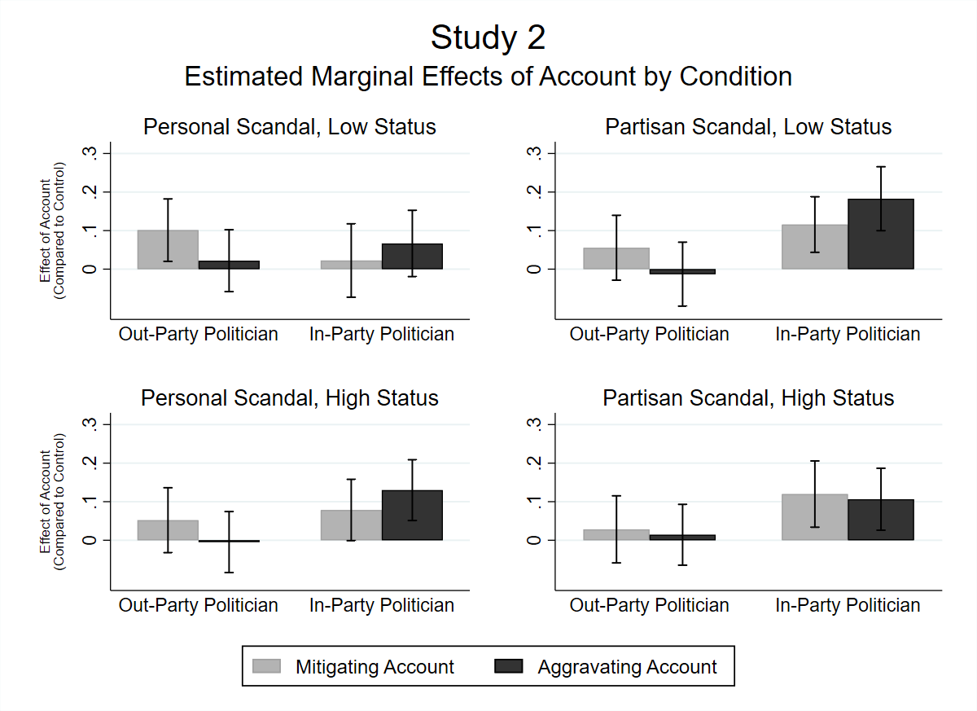
Figure 2. Estimated effects of aggravating accounts and of mitigating accounts on target evaluations, relative to the no-account control condition. Each bar represents the simple effect of that account in the specified condition. Error bars indicate 95% CIs. Estimates used to generate the figure are provided in Table 2. Participants who failed any memory check item are excluded in these models.

Discussion
We derived three conclusions from Study 2. First, our Defend-the-Group Hypothesis requires revision. Partisans respond favorably to aggravating accounts from in-party politicians, but they do not respond negatively to mitigating accounts. Although we were initially interested in whether, when, and why partisans’ group motives would incentivize politicians to deny rather than concede wrongdoing, it seems more appropriate now to ask whether, when, and why partisans tolerate aggravating accounts from their leaders. The second conclusion we drew from Study 2 is that individual differences in the identity-centrality of partisanship do not seem to exacerbate this tendency. But this does not mean that group-related motives cannot help to explain partisans’ susceptibility to aggravating accounts. On the contrary, our third set of analyses suggests that our participants responded positively to aggravating accounts from in-party politicians specifically when those politicians were directly connected to the party’s public image or when they acted to achieve the party’s goals.
However, the mixed significance of this last finding is a reminder that the difference between significant and non-significant is not necessarily itself statistically significant (Gelman & Stern, 2006), leaving room for uncertainty—in general, and in our case in particular. We therefore conducted additional exploratory analyses to help clarify why aggravating accounts “worked” only in the high-status or partisan scandal conditions.
First, to explore whether aggravating accounts improved evaluations of in-party politicians because they defended the public image of the party, we tested whether aggravating accounts decreased participants’ belief that “Wimsatt’s actions [would] harm the reputation of the [Democratic/Republican] Party.” They did; aggravating accounts from in-party politicians reduced participants’ endorsement of this statement by 15% of the scale’s full range (b = -0.15, 95% CI: -0.23, -0.07, p < 0.001). Second, we tested whether aggravating accounts reduced in-party participants’ belief that “Wimsatt’s actions” would cost the party votes or donations (an average of two items). They did, by 16% of the scale’s full range (b = -0.16, 95% CI: -0.23, -0.09, p < 0.001). Finally, we estimated two sets of moderated mediation models (see Figure 3) that revealed significant positive indirect effects of aggravating accounts on target evaluations via perceptions of reputational harm and anticipated loss of votes or donations.
It is therefore at least plausible that partisans’ motives to protect the esteem of their party and to pursue its political goals each help to explain partisans’ positive reactions to aggravating accounts. However, the exploratory measures above do not cleanly separate these motives; the belief that Wimsatt’s actions would damage his party’s reputation was correlated with the belief that he would cost it votes or donations at r = .76. We conducted Study 3 to distinguish image-defense motives from goal-defense motives and to provide additional evidence for each of these mechanisms given the fragile interaction effects in Study 2.

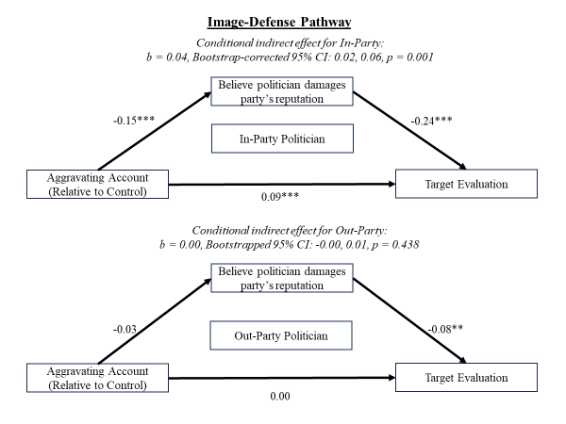
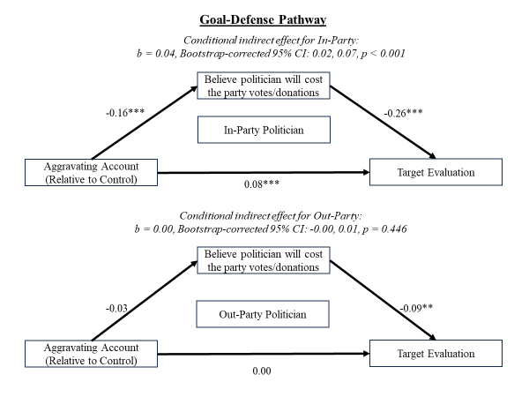
Figure 3. Exploratory Mediation Models from Study 2. The diagrams above represent two pairs of regression models: one predicting the mediator from aggravating accounts, in-partisanship, and their interaction, the other predicting target evaluations from the same variables, plus the mediator and its interaction with in-partisanship. CIs for indirect effects were estimated with 1,000 bootstrapped samples. Model estimates are reported in the supplement.
Study 3
Studies 1 and 2 yielded robust evidence that partisans are willing to accept aggravating accounts from in-party politicians but left unclear how much of this effect is due to partisans’ desire to protect their party’s collective esteem versus its concrete political goals. In Study 3, we modified our paradigm in two ways to more cleanly isolate these motives.
First, we manipulated the stakes of the scandal, such that the politician was either necessary or unnecessary for the party to accomplish its goals. If this manipulation increased participants’ preferences for aggravating accounts from in-party politicians, we would conclude that the desire to prevail in partisan conflict contributes to this preference. Meanwhile, if participants show a preference for aggravating accounts from in-party politicians even when the party’s goals are totally secure, then something else must contribute to that preference—such as the fact that aggravating accounts reaffirm the party’s positive public image.
Second, we created new outcome measures that distinguish participants’ willingness to vote for the errant politician from their evaluations of him. If aggravating accounts succeed because they exploit participants’ desire to prevail in partisan conflict, they should have a particularly strong effect on vote intentions; participants would want him to win even if they don’t like him. If aggravating accounts succeed because they help assure participants that their group is full of upstanding, moral people, though, they should improve evaluations of the politician (and perhaps the intention to support him).
Given the mixed results in Study 2, we also recruited a larger number of participants for Study 3, enough to more than double our previous target sample.
Method
Participants
We recruited another sample from Amazon’s Mechanical Turk (N = 2,172). This time, we used a pre-screening survey to exclude Independents (n = 365) before assigning participants to condition. We also gave participants the option to withdraw their data after we revealed deception in our debriefing, resulting in 5 further exclusions. The remaining sample (N = 1,771) included 600 men, 1,166 women and 4 nonbinary respondents. The mean age was 40.9 years (SD = 13.3 years). 1,356 identified as White, 167 as Black, 99 as Latino/Latina/Hispanic, 97 as Asian, 14 as Native American, and 35 as another race/ethnicity.
In addition, our study was displayed only to participants with U.S., non-Florida IP addresses. Our fictitious news story described a Florida state senator, and we did not want knowledgeable Floridians to see through our ruse—nor did we want to misinform Floridians about their legislators.
Materials and Procedure
Partisanship and Identity Centrality. Participants indicated their partisan affiliation using the same branching item as in Study 2. Study 3 included only Huddy et al.’s (2015) measure of partisan identity centrality.
News Story Manipulation. Our manipulation described a politician named Douglas Courser, “a senior [Republican/Democrat] in the Florida state senate” who had committed one of three crimes. The article depicted “Courser” using an image of Rep. Matt Gaetz (R-FL) doctored to include a lapel pin corresponding to his randomly assigned party. We used Gaetz’s image hoping that most non-Floridians would simply see a prototypically White, male, American politician, but we did ask participants whether they recognized the man in the photo and excluded any who correctly recalled his name, party, or elected office (n = 74). We collected data from August-September 2019, during Gaetz’s second Congressional term.
Political party. Courser was described as either a Democrat or a Republican.
Account. In the aggravating account condition, Courser said that the “so-called ‘scandal’” was “a desperate and disgusting attempt to smear [his] name—politics at its worst.” In the mitigating account condition, Courser said that he recognized that what he did was wrong, that words could not express his regret, and that he had only meant to provide for his family or shield them from his mistakes (depending on the scandal). The control condition included no account.
Stakes. In the high-stakes condition, the scandal was described as “bad news for [Democrats/Republicans]—both in Florida and in the country at large—who are counting on Courser to hold his seat.” Without his “pivotal vote” his party would lose a high-stakes redistricting battle with implications for policy in Florida and the 2020 presidential election. In the low-stakes condition, “[Democrats/Republicans] in Florida and in the rest of the country [were] unconcerned” because they were “accustomed to working with” the out-party to “accomplish shared policy aims [in the state].” The article predicted “no impact on the national scale.”
Scandal. In every story, Courser was accused of criminal wrongdoing for his personal gain—either a drunk-driving cover-up, campaign finance fraud, or tax evasion.
Attention and Manipulation Checks. Immediately after the news story, participants completed a series of multiple-choice questions about Courser’s political party, his response to the allegations, and how concerned other partisans were about the consequences of his actions. We call these “attention” rather than “memory” checks in Study 3 because this time the article remained on the screen while participants answered, to give them an additional chance to notice details they may have missed at first glance.
To test whether participants in the high-stakes condition 1) encoded the stakes as high and 2) personally cared about Courser’s re-election, we asked participants how difficult it would be for Courser’s party to pass desired laws and win elections at the state and national level (α = .85) and whether they preferred that Courser win or lose reelection. Participants in the high-stakes condition expected more difficulty (b = 0.30, 95% CI: 0.28, 0.32, p < 0.001) and—when they identified with Courser’s party—showed a stronger preference for his reelection (b_{stakes} = 0.21, 95% CI: 0.18, 0.25, p < 0.001). Out-party participants wanted Courser to lose regardless of the stakes (b_{stakes} = -0.02, 95% CI: -0.06, 0.01, p = .184).
Dependent Variables and Potential Mediator
Trait evaluations. Participants completed the same semantic-differential-like trait items described in Study 1 (plus one item for “skillful” to help balance warmth and competence-related items; α = .92).
Intent to support. Participants indicated 1) their willingness to sign a petition on Courser’s behalf and whether they would vote for him 2) in the general or 3) primary elections in Florida if they could (α = .76).
Perceived Image Threat. Because this study did not manipulate Courser’s threat to his party’s image, we instead measured the extent to which Courser’s actions made his party look bad (or good) and how proud or embarrassed participants thought that fellow partisans were to have Courser in their party. These items were rescaled to range 0-1 and averaged in a single “perceived image threat” variable (α-_{Republican} = .60; α-_{Democrat} = .64).
Demographics and Exploratory Variables. We asked participants several additional questions that might have helped us to clarify ambiguous results, such as whether they thought the state of Florida or the country would be better off if Courser won, trait evaluations of the major parties, and political knowledge. We also retained some of our previous studies’ dependent variables that were not neatly categorizable as “trait evaluations” or “intent to support” and therefore were not used in Study 3 analyses. All items are presented in the supplement.
Results
Inclusion Criteria
We excluded participants who incorrectly answered any of our attention check questions or who recognized the true name, party identification, or position of the politician pictured in our fake news story (who was supposedly Douglas Courser but was in fact Matt Gaetz). We tested whether exclusions were balanced across conditions and found that participants were disproportionately excluded from the aggravating account condition (χ²(2) = 19.80, p < .001). A logistic regression (see supplement) revealed that this imbalance was not significant for higher-order interactions involving aggravating accounts, but we ran all analyses with and without planned exclusions so that readers can draw their own conclusions from any differences.
Replicating Study 1 and Exploring Variability Across Scandals
We first re-estimated the models presented in Table 1 using each Study 3 outcome (Models 1.3 and 1.4). Note that we did not necessarily predict exact replication because Study 3 introduced a “low stakes” condition expected to reduce partisans’ preference for aggravating accounts. Still, three patterns were consistent across all three studies. First, aggravating accounts always improved participants’ reactions to in-party politicians and only in-party politicians (though the associated interaction was non-significant in Model 1.4). Second, the effects of mitigating accounts (which were either null or small and positive) never significantly depended on politician partisanship. Finally, the strength or identity centrality of participants’ partisanship never moderated the effects of accounts (Study 3 ps > 0.25; not depicted in Table 1). No results differed if we removed our inclusion criteria.
Exploring Variability Across Scandals
We also estimated mixed linear models to determine whether the effects of accounts emerged consistently across scandal scenarios (drunk driving cover-up, embezzling campaign funds, tax evasion). Analyses reported fully in the supplement suggest that they did. As in Study 1, all effects differed only trivially across scenarios, with all slopes’ variance estimates less than 0.001 (which is less than 7% of any coefficient’s standard error in the model).
New Tests of the Image-Defense and Goal-Defense Hypotheses
To test both the Image-Defense and Goal-Defense hypotheses, we estimated a pair of regressions predicting trait evaluations and supportive intentions from indicator variables for the scandal’s stakes (low or high), the politician’s party (outgroup or ingroup), his account (mitigating or aggravating, relative to control), and all interactions among these variables. Estimates for both models appear in Table 3.
As a further test of the Image-Defense Hypothesis, we also estimated mediation models to test whether aggravating accounts improved reactions to Courser to the extent that they made the party look less bad. We did not use a mediation model to test the Goal-Defense hypothesis because we did not expect aggravating accounts to increase the perceived stakes of Courser’s re-election. Rather, we expected aggravating accounts to increase support for Courser when the stakes of his re-election were high (due to our experimental manipulation)—a variable that we measured but did not manipulate in Study 2.

Table 3. Trait Evaluations and Intent to Support as a function of all Study 3 manipulations
 |  | Model 3.1. Trait Evaluations |  |  |  |  |  |  | Model 3.2. Intent to Support
Predictor |  | b |  |  | 95% CI |  | p |  | b |  | 95% CI | p
In-Party Politician |  | 0.07** |  |  | [0.03, 0.11] |  | 0.002 |  | 0.14*** |  | [0.09, 0.19] | < 0.001
Mitigating Account  Aggravating Account |  | 0.03 |  |  | [-0.01, 0.08] |  | 0.111 |  | 0.02 |  | [-0.03, 0.06] | 0.417
 |  | 0.01 |  |  | [-0.03, 0.05] |  | 0.672 |  | 0.04 |  | [-0.01, 0.09] | 0.130
Low Stakes |  | 0.02 |  |  | [-0.02, 0.06] |  | 0.350 |  | 0.00 |  | [-0.05, 0.05] | 0.997
Mitigating Acct X In-Party |  | 0.06* |  |  | [0.01, 0.12] |  | 0.032 |  | 0.09** |  | [0.02, 0.15] | 0.009
Aggravating Acct X In-Party |  | 0.08* |  |  | [0.02, 0.14] |  | 0.012 |  | 0.10** |  | [0.03, 0.17] | 0.003
In-Party X Low Stakes |  | -0.01 |  |  | [-0.07, 0.04] |  | 0.625 |  | 0.00 |  | [-0.07, 0.06] | 0.94
Aggravating Acct X Low Stakes |  | -0.05 |  |  | [-0.11, 0.01] |  | 0.129 |  | -0.01 |  | [-0.08, 0.05] | 0.708
Mitigating Acct X Low Stakes |  | 0.01 |  |  | [-0.05, 0.07] |  | 0.728 |  | 0.01 |  | [-0.05, 0.08] | 0.698
Aggr. Acct X Low Stakes X In-Party |  | -0.03 |  |  | [-0.11, 0.06] |  | 0.546 |  | -0.13** |  | [-0.23, -0.04] | 0.007
Mit. Acct X Low Stakes X In-Party |  | -0.06 |  |  | [-0.14, 0.02] |  | 0.165 |  | -0.14** |  | [-0.23, -0.05] | 0.003
Intercept |  | 0.23*** |  |  | [0.20, 0.26] |  | < 0.001 |  | 0.03† |  | [-0.00, 0.06] | 0.094
F(df) |  |  |  | 17.27*** (11, 1,451) |  |  |  |  |  | 34.19*** (11, 1,448)
R² |  |  |  |  |  | 0.12 |  |  |  |  | 0.21
N |  |  |  |  |  | 1,463 |  |  |  |  | 1,460
Entries are estimates from an OLS regression of target evaluations (scaled to range from 0 to 1) on indicator variables for experimental conditions and the interactions between these indicators, using data from Study 3. The reference group for the mitigating and aggravating account indicators is the control account. The remaining indicators are from binary variables (in-party vs. out-party politician; low vs. high stakes) Participants who failed at least one attention check item or recognized the politician in the article photo are excluded from these models.
† p < 0.1, * p < 0.05, ** p < 0.01, *** p < 0.001

Image-Defense Hypothesis. If aggravating accounts improve partisans’ evaluations of in-party politicians because they make the party look good—or at least contest allegations that make the party look bad—then they should improve evaluations of in-party politicians (and perhaps increase intent to support them) regardless of whether the party needs the politician to enact its agenda. We find weak support for this hypothesis. On one hand, the non-significant 3-way interaction in Model 3.1 indicates that the positive effect of aggravating accounts for in-party politicians was not significantly weaker when the stakes were low. On the other hand, the conditional effect of aggravating accounts for in-party politicians is significant in the high- but not the low-stakes condition (b_{high-stakes} = 0.09, 95% CI: .05, .13, p < 0.001; b_{low-stakes} = 0.01, 95% CI: -.03, .06, p = 0.511; see Figure 4, upper panels), consistent with this hypothesis. Model 3.2, predicting intent to support Courser, is more clear-cut. Aggravating accounts increased support for in-party politicians only when the stakes were high, and their effect in the low-stakes condition was significantly weaker and near 0. See Figure 4, lower panels.
Our mediation analyses complicate these results somewhat. They revealed small but significant indirect effects of aggravating accounts on both trait evaluations and supportive intentions via perceived image threat—even when stakes were low. See Figure 5. Perhaps high-stakes situations magnify partisans’ concern with their party’s public image.
Goal-Defense Hypothesis. If aggravating accounts improve partisans’ reactions to in-party politicians because they exploit partisans’ desire to win, then they should have the strongest effects when the party’s policy goals are at stake. The significant 3-way interaction in Model 3.2 is consistent with this possibility. So too is the fact that this interaction emerged in the model predicting intentions to support Courser but not in the model predicting trait evaluations; in-partisans didn’t like Courser any better when the stakes were high, but they were more willing to help him stay in office. See Figure 4.
Impact of Exclusions on Results. Our supplement presents alternative versions of Models 3.1 and 3.2 including participants who failed attention checks or recognized Gaetz. In these models, some unexpected interactions with mitigating accounts dropped to non-significance, but, more important, so did the Aggravating x In-Party x Low Stakes interaction in Model 3.2 that tests our Goal-Defense Hypothesis. It is therefore possible that differential exclusion across conditions inflated the focal three-way interaction and support for the Goal-Defense Hypothesis. That said, it is also possible that adding over 150 participants who failed our attention checks increased noise in our analysis. Regardless, the conditional effects of aggravating accounts tell a consistent story: aggravating accounts had a significant and positive effect on intentions to support Courser only in the high stakes, in-party condition, regardless of whether we include or exclude those participants. Compare Figure 4 to Supplemental Figure A2.
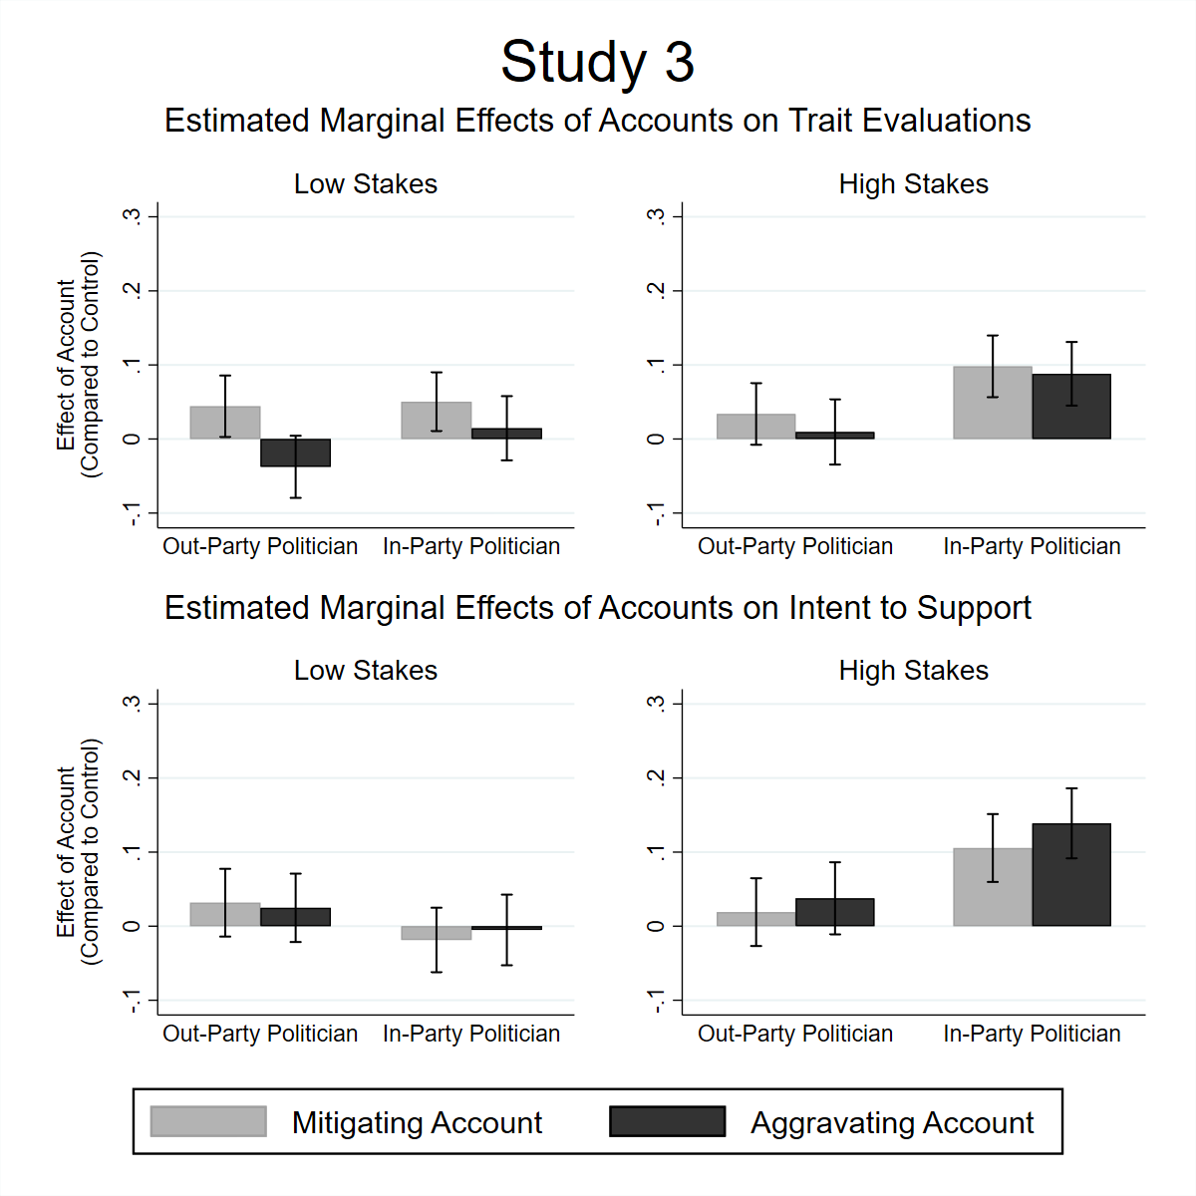
Figure 4. Estimated effects of aggravating accounts and of mitigating accounts on trait evaluations and intent to support Courser, relative to the no-account control condition. Each bar represents the estimated effect of that account in the specified condition. Error bars indicate 95% CIs. Estimates used to generate the figure are provided in Table 3. Participants who failed any attention check item or recognized the politician in the photo are excluded in these models.

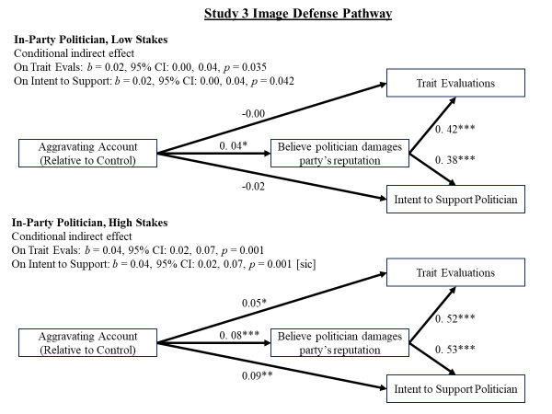
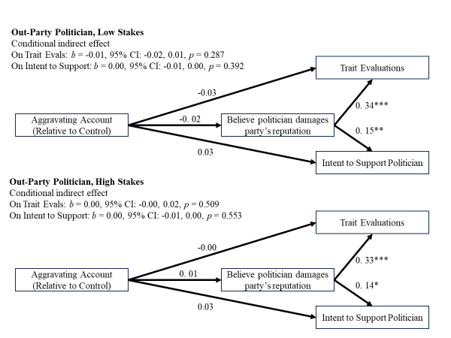
Figure 5. Mediation Models from Study 3. The diagrams above represent two trios of regression models: one predicting the mediator from aggravating accounts, in-partisanship, and their interaction, and one predicting each from the same variables plus the mediator and its interaction with in-partisanship. CIs for indirect effects were estimated with 1,000 bootstrapped samples. Model estimates are reported in the supplement.

Discussion
Once again, we find that partisans evaluate in-party politicians more favorably when they use aggravating accounts to defend their misconduct. They also report being more likely to vote for these politicians. This tendency was at least related to how participants thought Courser’s actions would affect his party’s public image. However, in low-stakes elections, partisans’ preference for aggravating accounts all-but disappeared, suggesting that their willingness to tolerate Courser’s contentious rhetoric had more to do with motives to gain and retain political power than with motives to feel good about themselves and their group.
General Discussion
Conclusions and Limitations.
Partisan participants preferred (or at least tolerated) politicians who defended their ingroup. Across all three experiments, we found partial support for our Defend-the-Group Hypothesis. Politicians engaged in clearly unethical—even illegal—behavior won more positive evaluations from co-partisans when they employed aggravating accounts. However, they did not incur the ire we expected when they used mitigating accounts. Partisans did not punish their leaders for apologizing, but their tolerance for aggravating accounts (which out-partisans uniformly rejected) could allow politicians to avoid uncomfortable admissions of guilt and any consequent demands that they improve their behavior or leave office.
Partisan participants tolerated aggravating accounts because they wanted to win. We predicted that aggravating accounts would be successful among in-partisans for two reasons. First, they affirm partisans’ social identities. Second, they tell partisans that their leader intends to retain political power.
Both motives presumably arise from group attachment, but the effects of accounts were consistent regardless of how strongly or weakly participants identified with their party—even in Studies 2 and 3, in which participants sometimes read about low status politicians acting for their personal gain in low-stakes elections. Evidence did not support our Identity-Centrality Hypothesis.
Support for the Image-Defense hypothesis was more mixed. In Study 2, participants showed less favorable reactions to aggravating accounts when they came from low- rather than high-status members of their party—but not always significantly so. In Studies 2 and 3, aggravating accounts consistently reduced participants’ perceptions that in-party scandals put their party’s reputation at risk, and these perceptions, in turn, consistently predicted more positive evaluations of in-party politicians. But the total effect of aggravating accounts on reactions to in-party politicians vanished when we lowered the stakes of their reelection, suggesting that other considerations outweighed participants’ collective image concerns—perhaps explaining why identity centrality did not play the moderating role that we expected.
We found the most robust support for the Goal-Defense Hypothesis. In Study 2, participants showed a (marginally) stronger preference for aggravating accounts when politicians misbehaved to secure benefits for their party, and in Study 3 they expressed more willingness to support politicians who denied their misconduct when their party needed them. When these politicians were disposable, in contrast, aggravating accounts had no effect. These results suggest that partisans are content for their leaders to deny misconduct specifically when they need those leaders to further party goals.
In sum, both weak and strong partisans in our study responded favorably to party leaders who assured them that they were not crooks, but only to the extent that their party needed that particular leader—crook or not.
Remaining questions. Although our experiments allow us to draw causal inferences, we cannot be certain how well our findings would generalize beyond our sample or stimuli. Our studies relied on MTurk workers, who are younger, more liberal, and less affluent than the American population (Huff & Tingley, 2015), and they certainly don’t represent the full population of political partisans across the globe who might perceive and react to misconduct by political leaders. Our news stories presented participants with imaginary politicians, all men, probably all presumed to be White. Partisans might be less willing to tolerate aggravating accounts from women or other groups historically excluded from elected office. And although we did vary the specific misconduct alleged against our fictitious politicians—and find robust effects—the universe of potential misconduct is far larger than we could explore in one paper, as politicians’ variegated journeys through that universe make clear.
Future work should also examine how individuals’ reactions to accounts manifest themselves in real-world elections. We presented participants with unfamiliar (indeed, fictitious) politicians and measured their attitudes and behavioral intentions; elections present citizens with candidates whom they know and ask them to choose one candidate over the other. The processes we investigated may not sway actual votes.
Implications
These findings have implications for research in multiple domains. First, in the broader social-identity and intergroup relations literature, partisans’ unique susceptibility to aggravating accounts can be understood as a specific case of ingroup favoritism (Tajfel, 1982). Although ingroup favoritism in general is well established, our study helps clarify precisely when and why ingroup favoritism might manifest in individuals’ responses to alleged misconduct by ingroup leaders. Specifically, we find that the shared group membership seems to have the strongest effect on how people respond to aggravating accounts. In our studies, mitigating accounts tended to modestly improve evaluations of errant politicians regardless of the partisanship of their audience, suggesting the “universal” power of politeness norms (Brown & Levinson, 1978). Aggravating accounts, in contrast, only helped when participants had reason to perceive a scandal through the lens of intergroup conflict. Shared group membership therefore allowed, but did not require, politicians to justify or deny their wrongdoing and eschew concessions. Groups that are less wholly defined by overt conflicts with other groups (e.g., race, gender) may or may not inspire similar biases.
Second, prior literature has searched high and low for circumstances that can reduce partisans’ biases in favor of their party (see Leeper & Slothuus, 2014, for a review). Our findings (and specifically the fact that all of our model intercepts fell well below the evaluative midpoint, 0.5) suggest that people may, in fact, dislike politicians who are accused of wrongdoing and subsequently offer no comment on their behavior, even when they belong to the same party.
However, these politicians seem to have considerable leeway to minimize, defend, or deny their wrongdoing. Politicians may be able to capitalize on partisan constituents’ motives to see their party in a favorable light and—more important—to see their party win by engaging in defensive or inflammatory rhetoric that might be offensive in interpersonal contexts in which group identity is not salient. Only co-partisans tolerated this defensive rhetoric; aggravating accounts never significantly improved participants’ evaluations of out-party politicians. But in the U.S., politicians can often succeed largely with in-party support (Holbrook & McClurg, 2005). And circumstances in contemporary American politics seem likely to increase in-partisans’ tolerance (if not demand) for—aggravating accounts. The politicians in question are certainly high-status—a former president stands indicted for alleged violations of federal and state laws. And given that the control of the legislature, presidency, and even the Supreme Court has recently and repeatedly depended on a handful of close elections, the stakes of elections to come are likely high as well. To the extent that our results generalize beyond these experiments, contemporary American politicians will find little incentive to be forthright or contrite about their misconduct, if and when it is revealed to the public.
Although our results suggest that citizens will not blindly follow party cues and evaluate co-partisan politicians positively regardless of their alleged misconduct, they also reveal a strategy that politicians may use to escape accountability. To the extent that such accountability is important for the functioning of democratic societies, partisans’ willingness to indulge hostile rhetoric might hazard the integrity of the democratic process—such as it is.

References
Anduiza, E., Gallego, A., & Muñoz, J. (2013). Turning a blind eye: Experimental evidence of partisan bias in attitudes toward corruption. Comparative Political Studies, 46, 1664-1692.
Benoit, W. L., & Drew, S. (1997). Appropriateness and effectiveness of image repair strategies. Communication Reports, 10, 153-163.
Bhatti, Y., Hansen, K. M., & Olsen, A. L. (2013). Political hypocrisy: The effect of political scandals on candidate evaluations. Acta Politica, 48, 408-428.
Brown, P. & Levinson, S. C. (1987). Politeness: Some universals in language usage. Cambridge: Cambridge University Press.
Campbell, A., Converse, P. E., Miller, W. E., & Stokes, D. E. (1960). The American voter. New York: John Wiley.
Chanley, V., Sullivan, J. L., Gonzales, M. H., & Kovera, M. B. (1994). Lust and avarice in politics: Damage control for four politicians accused of wrongdoing (or, politics as usual). American Politics Quarterly, 22, 297-333.
Cohen, P., Cohen, J., Aiken, L. S., & West, S. G. (1999). The problem of units and the circumstance for POMP. Multivariate Behavioral Research, 34, 315-346.
Costa, M., Briggs, T., Chahal, A., Fried, J., Garg, R., Kriz, S., Lei, L., Milne, A., & Slayton, J. (2020). How partisanship and sexism influence voters’ reactions to political #MeToo scandals. Research & Politics, 7(3). https://doi.org/10.1177/2053168020941727
Crocker, J., & Major, B. (1989). Social stigma and self-esteem: the self-protective properties of stigma. Psychological Review, 96, 608-630.
Diehl, M. (1990). The minimal group paradigm: Theoretical explanations and empirical findings. European Review of Social Psychology, 1, 263-292.
Dimock, M. A, & Jacobson, G. C. (1995). Checks and choices: The House Bank scandal’s impact on voters in 1992. The Journal of Politics, 57, 1143-1159.
Gelman, A., & Stern, H. (2006). The difference between “significant” and “not significant” is not itself statistically significant. The American Statistician, 60, 328-331.
Gonzales, M. H., Kovera, M. B., Sullivan, J. L., & Chanley, V. (1995). Private reactions to public transgressions: Predictors of evaluative responses to allegations of political misconduct. Personality and Social Psychology Bulletin, 21,136-148.
Gonzales, M. H., Manning, D. J., & Haugen, J. A. (1992). Explaining our sins: Factors influencing offender accounts and anticipated victim responses. Journal of Personality and Social Psychology, 62, 958-971.
Gonzales, M. H., Pederson, J., Manning, D. J., & Wetter, D. W. (1990). Pardon my gaffe: Effects of sex, status, and consequence severity on accounts. Journal of Personality and Social Psychology, 58, 610-621.
Holbrook, T. M. & McClurg, S. D. (2005). The mobilization of core supporters: Campaigns, Turnout, and electoral composition in United States presidential elections. American Journal of Political Science, 49, 689-703.
Huddy, L., Mason, L., & Aarøe, L. (2015). Expressive partisanship: Campaign involvement, political emotion, and partisan identity. American Political Science Review, 109, 1-17.
Huff, C., & Tingley, D. (2015). “Who are these people?” Evaluating the demographic characteristics and political preferences of MTurk survey respondents. Research & Politics, 2(3).
Leeper, T. J., & Slothuus, R. (2014). Political parties, motivated reasoning, and public opinion formation. Political Psychology, 35, 129-156.
Locksley, A., Ortiz, V., Hepburn, C. (1980). Social categorization and discriminatory behavior: Extinguishing the minimal intergroup discrimination effect. Journal of Personality and Social Psychology, 39, 773-783.
Luhtanen, R., & Crocker, J. (1992). A collective self-esteem scale: Self-evaluation of one’s social identity. Personality and Social Psychology Bulletin, 18, 302-318.
Mason, L. (2018). Uncivil agreement: How politics became our identity. University of Chicago Press.
McCullough, M. E., Worthington, E. L., Jr., & Rachal, K. C. (1997). Interpersonal forgiving in close relationships. Journal of Personality and Social Psychology, 73, 321–336.
McGraw, K. M. (1990). Avoiding blame: An experimental investigation of political excuses and justifications. British Journal of Political Science, 20, 119-131.
McGraw, K. M. (1991). Managing blame: An experimental test of the effects of political accounts. The American Political Science Review, 85, 1133-1157.
McGraw, K. M., Best, S., & Timpone, R. (1995). “What they say or what they do?” The impact of elite explanation and policy outcomes on public opinion. American Journal of Political Science, 39, 53-74.
McGraw, K. M., Timpone, R., & Bruck, G. (1993). Justifying controversial political decisions: Home Style in the laboratory. Political Behavior, 15, 289-308.
McLaughlin, M. L., Cody, M. J., & O’Hair, H. D. (1983). The management of failure events: Some contextual determinants of account behavior. Human Communication Research, 9, 208-224.
Schönbach, P. (1990). Account episodes: The management or escalation of conflict. Cambridge: Cambridge University Press.
Sherif, M., Harvey, O. J., Hood, W. R., & Sherif, C. W. (1961). Intergroup conflict and group relations: The robbers cave experiment. The Institute of Group Relations, Norman, OK.
Scott, M. B. & Lyman, S. M. (1968). Accounts. American Sociological Review, 33, 46-62.
Tajfel, H. (1970). Experiments in intergroup discrimination. Scientific American, 223, 96-103.
Tajfel, H., & Turner, J. C. (1986). The social identity theory of intergroup behavior. In S. Worchel & W. G. Austin (Eds.), Psychology of intergroup relations (2nd ed., pp. 7-24). Chicago: Nelson-Hall.

Nor did we find significant evidence that extremity of partisan identification or a composite that combined the two identity centrality scales moderated participants’ reactions to accounts (across 40 possible interactions in 8 models, all ps > 0.05; two ps < 0.10).
Due to a coding error, both of these questions were delivered in an 11-point response format in the Republican condition and in a 7-point branched format in the Democrat condition. We therefore report a separate alpha for each condition.
We recruited only non-Floridians and our debriefing made clear that the scandal and politician were fictitious.

